**Saeid Niknam Esfahani**

**CYBR410-T301 Data/Database Security - Bellevue University**

**Module 8.2 – written assignment**

**Professor Peter Haas**

**July 24th, 2023**

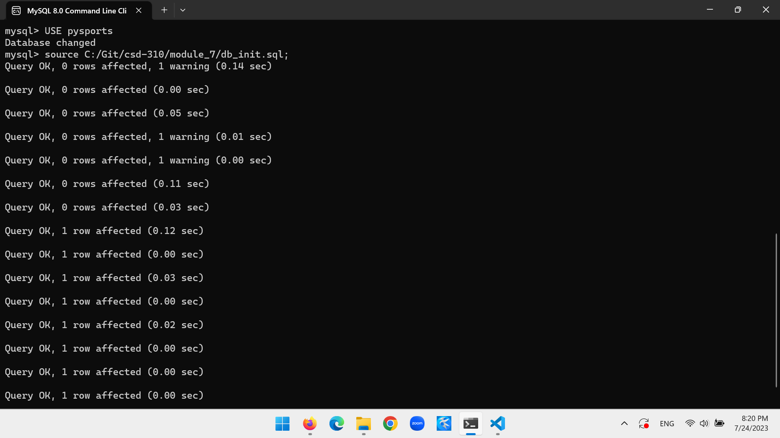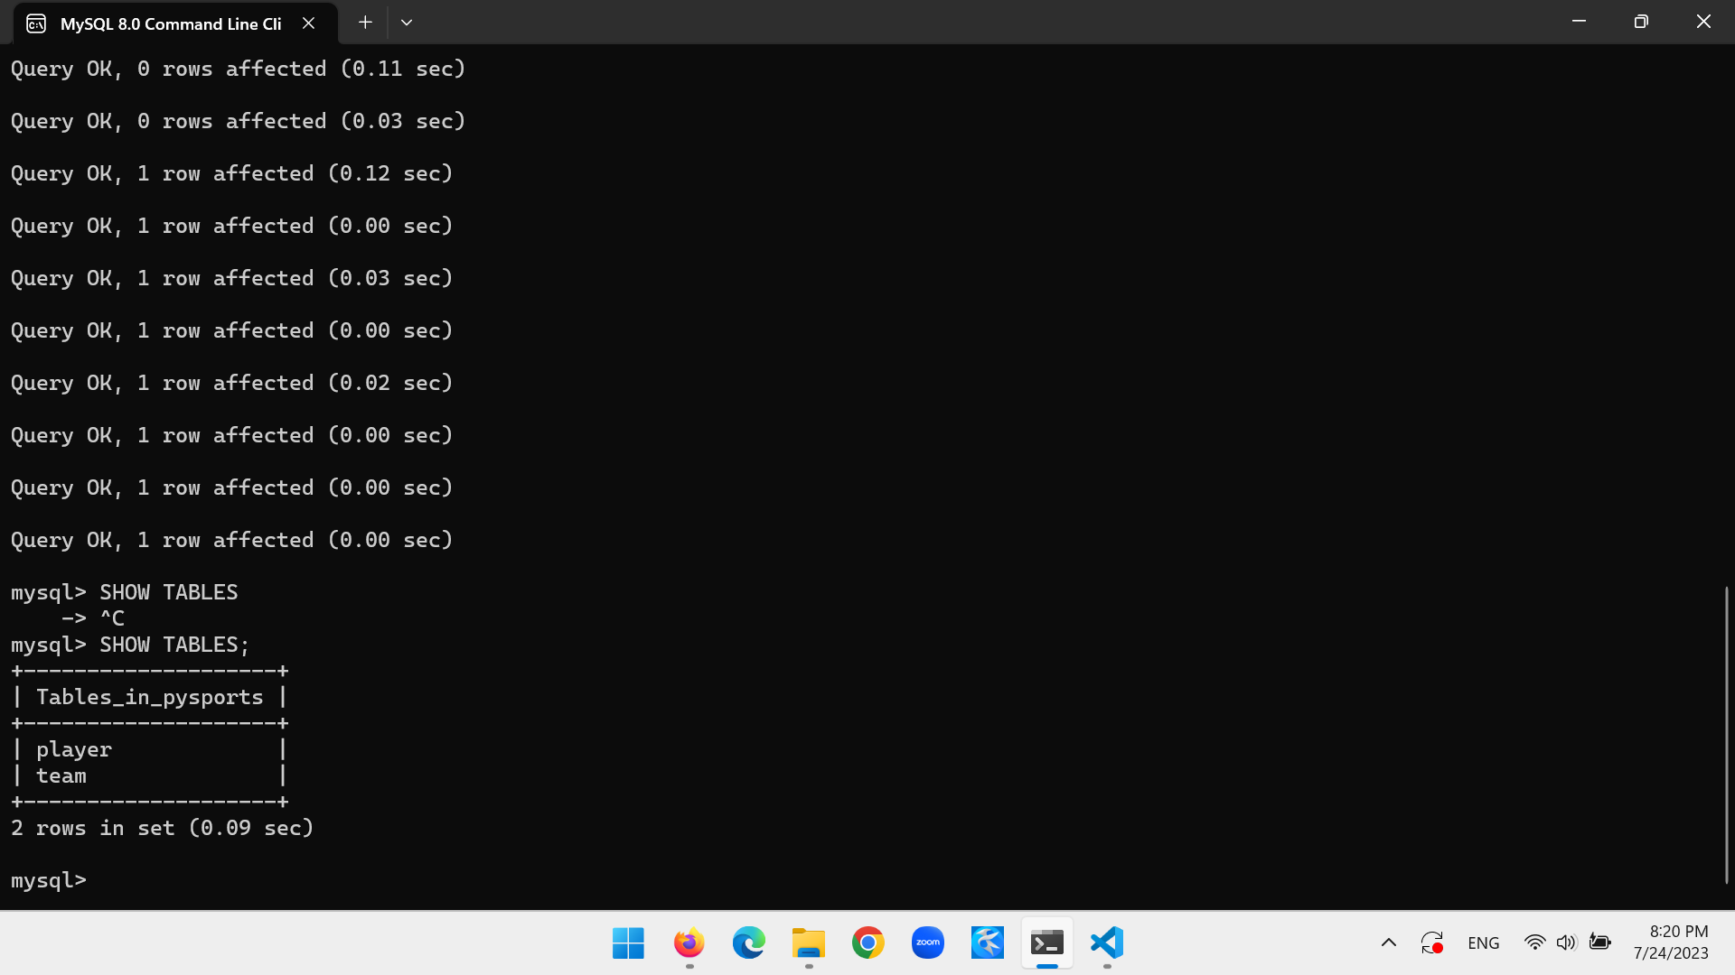

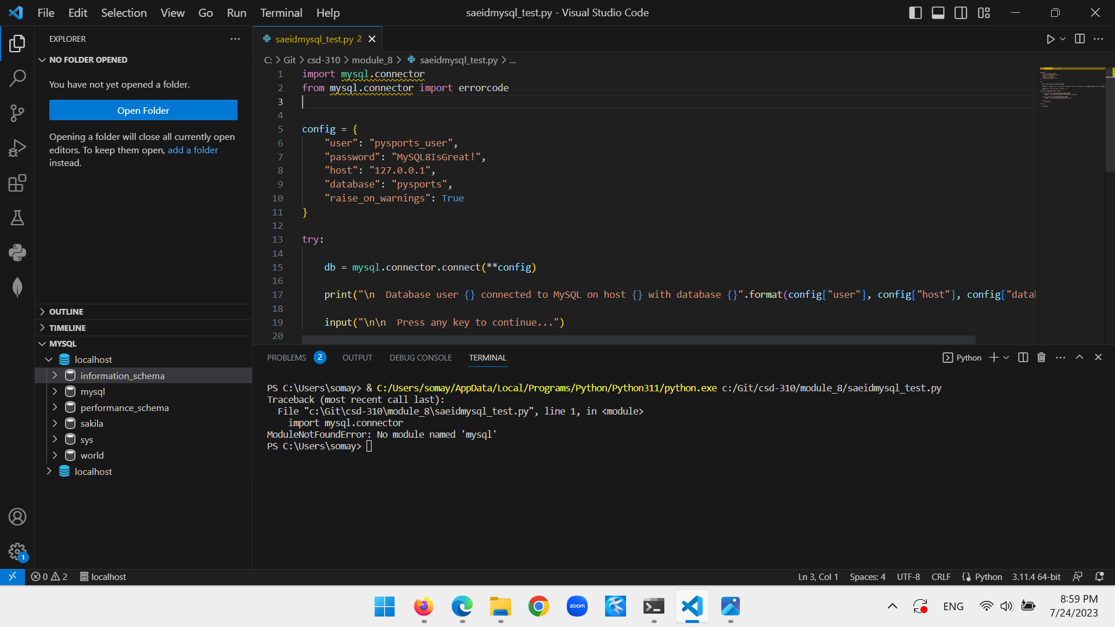

Dear Professor Haas,

As it is clear in the last picture, I could successfully connect VS code to MySQL/localhost, however, since my Python did not recognize ‘mysql.connector’, it gave me error as I ran the code, and I could not verify the results. Everything else in this assignment is done.

Sincerely

Saeid